

**Northeastern University**

**CSYE 7105 High-Performance Parallel**

**Machine Learning & AI, Spring 2025**

**Instructor:** Dr. Handan Liu

**Team 4:** Ram Kumar Ramasamy Pandiaraj

**Project Report**

Topic:

**Analysis of Efficient Parallel Computing for Deep Learning-Based Glaucoma Detection**

Table of Contents

1. Introduction: 3

1.1 Background: 3

1.2 Motivation: 3

1.3 Goal: 3

2. Methodology 4

2.1 Dataset Description: 4

2.1.1 Data Splits and Class Distribution 4

2.1.2 Image Characteristics 5

2.2 Data Preprocessing: 6

2.3 Model Architecture: 8

2.4 Parallelization Techniques: 9

**2.4.1 Distributed Data Parallel on CPUs and GPUs:** 10

**2.4.2 DDP + AMP on GPU:** 13

**2.4.3 DDP + AMP + Model Parallel on GPU** 14

3. Result and Analysis 15

3.1 Selecting Right Batch Size 15

3.2 Accuracy check 16

3.3 Training on Single vs Multiple CPUs 17

3.3.1 Speedup 19

3.3.2 Efficiency 19

3.4 Training on GPUs 20

3.5 Multiple GPUs Performance: 21

3.5.1 With DDP: 21

3.5.2 With DDP + AMP: 23

3.5.3 With DDP + AMP + Model Parallel: 25

4. Conclusion: 26

5. References: 27

# Introduction:

## 1.1 Background:

Glaucoma is a chronic and progressive eye disease that damages the optic nerve and can lead to irreversible blindness. It affects more than 80 million people worldwide and is projected to impact over 110 million by 2040 [1]. Diagnosis of glaucoma often involves the analysis of fundus photographs, which are high-resolution images capturing the back of the eye. While these images offer valuable visual clues, their interpretation requires significant expertise and time, making the process slow, subjective, and inaccessible in many parts of the world.

Traditional diagnostic methods such as visual field tests and intraocular pressure measurement are time-consuming and sometimes ineffective for early-stage detection. The use of automated systems powered by deep learning - especially convolutional neural networks (CNNs) with accelerated computing - has emerged as a promising solution for improving accuracy and scalability in glaucoma screening. However, the computational demands of training such systems on large, high-resolution medical image datasets pose significant challenges in terms of time, resource usage, and scalability.

## 1.2 Motivation:

Although CNN-based models have shown encouraging results for automated glaucoma detection, the practical implementation of these models at scale remains difficult due to their high computational cost. High-resolution fundus images require intensive preprocessing, complex feature extraction, and long training cycles - especially when leveraging deeper CNN architectures or attention mechanisms. These challenges are exacerbated in real-world clinical environments where computational resources may be limited, and time efficiency is critical.

To address these limitations, this project explores the application of parallel and distributed computing techniques to optimize deep learning pipelines for glaucoma detection. By distributing the computational workload across multiple CPUs and GPUs using tools like DistributedDataParallel (DDP), Automatic Mixed Precision, and Model Parallelism Techniques, we aim to drastically reduce training time while maintaining or improving model performance. The successful implementation of such a system in clinical spaces could enhance the feasibility of using AI-based glaucoma detection in diverse clinical and telemedicine settings.

## 1.3 Goal:

The objective of this project is to implement and optimize a deep learning-based glaucoma detection system using the SMDG-19 dataset, while systematically exploring the impact of parallel computing strategies on training time, scalability, and resource utilization. Using Northeastern University’s OOD Explorer cluster, we evaluate the performance of different parallelization methods - including multi-GPU training and parallel data loading - under various hardware configurations. This analysis not only benchmarks the gains in efficiency but also identifies the best practices for deploying such models in high-performance computing environments. Ultimately, the project aims to bridge the gap between AI capability and real-world deployment by demonstrating how parallel computing can make medical image analysis both scalable and practical.

To achieve the research vision of enabling scalable and efficient glaucoma detection through deep learning, this project focuses on the following key objectives:

1. **Enhancing Data Processing Efficiency**: Build a custom preprocessing pipeline with resizing, normalization, CLAHE, gamma correction, and denoising.  
   These steps improve optic disc visibility, reduce noise, and provide consistent input for training. Also perform Augmentation to address class imbalance, improving generalization and accelerating convergence.
2. **Improving Scalability and Resource Utilization**: Design and implement a training pipeline that utilizes parallel computing on both CPUs and GPUs. Through strategies like Distributed Data Parallelism (DDP), multi-processing, and model parallelism, the system dynamically scales across available compute resources, ensuring efficient memory and compute usage.
3. **Optimizing Deep Learning Model Training**: Train a custom 129-layer CNN model with over 22 million parameters, designed with residual blocks, SE attention mechanisms, and multi-dilated convolutions. Implement mixed precision training (AMP) to accelerate convergence and reduce memory usage, while evaluating combinations like DDP + AMP and DDP + AMP + Model Parallelism for best runtime efficiency.
4. **Benchmarking Performance and Scalability**: Systematically compare training time, GPU utilization, memory consumption, and model accuracy across serial and parallel implementations. Identify communication bottlenecks and assess the trade-offs of each parallelization method across different CPU/GPU configurations.

By accomplishing these objectives, the project aims to demonstrate how high-performance computing can enable the real-world deployment of complex AI models for medical imaging.

# Methodology

Before diving into core implementation methodologies let’s go over the dataset split.

## 2.1 Dataset Description:

The dataset used in this project is the [**SMDG-19 fundus image dataset**](https://www.kaggle.com/datasets/sabari50312/fundus-pytorch/), curated for binary classification of glaucoma versus normal eye conditions. The total dataset consists of 17,242 high-resolution color fundus images, all of which were standardized and preprocessed for optimal model performance.

### 2.1.1 Data Splits and Class Distribution

The dataset is divided into training, validation, and test splits with the following structure:

* Training Set: 5,293 Normal (Class 0), 3,328 Glaucoma (Class 1), *Total: 8,621 images*
* Validation Set: 3,539 Normal, 2,208 Glaucoma, *Total: 5,747 images*
* Test Set: 1,754 Normal, 1,120 Glaucoma, *Total: 2,874 images*

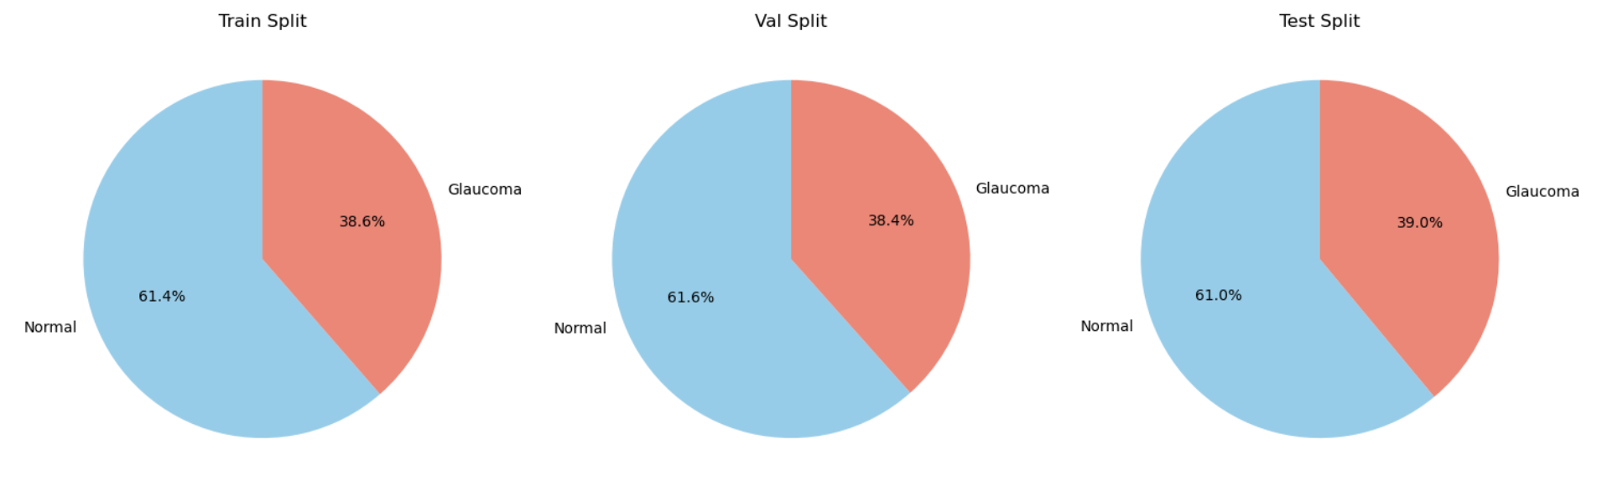

***Figure 1: Class Distribution of dataset***

Each split maintains a consistent class ratio of ~61% Normal to ~39% Glaucoma, as illustrated in the pie charts (Figure 1) and bar graph (Figure 2). This ensures that the model is evaluated on a balanced set while also recognizing the mild class imbalance present in real-world clinical datasets.

### 2.1.2 Image Characteristics

Each image has a native resolution of **512×512 pixels** and contains **three RGB color channels**. Aspect ratio analysis confirmed a consistent 1:1 ratio across all images, ensuring no distortion or resizing artifacts during preprocessing (Figure 3). All images were stored in PNG format to preserve quality.

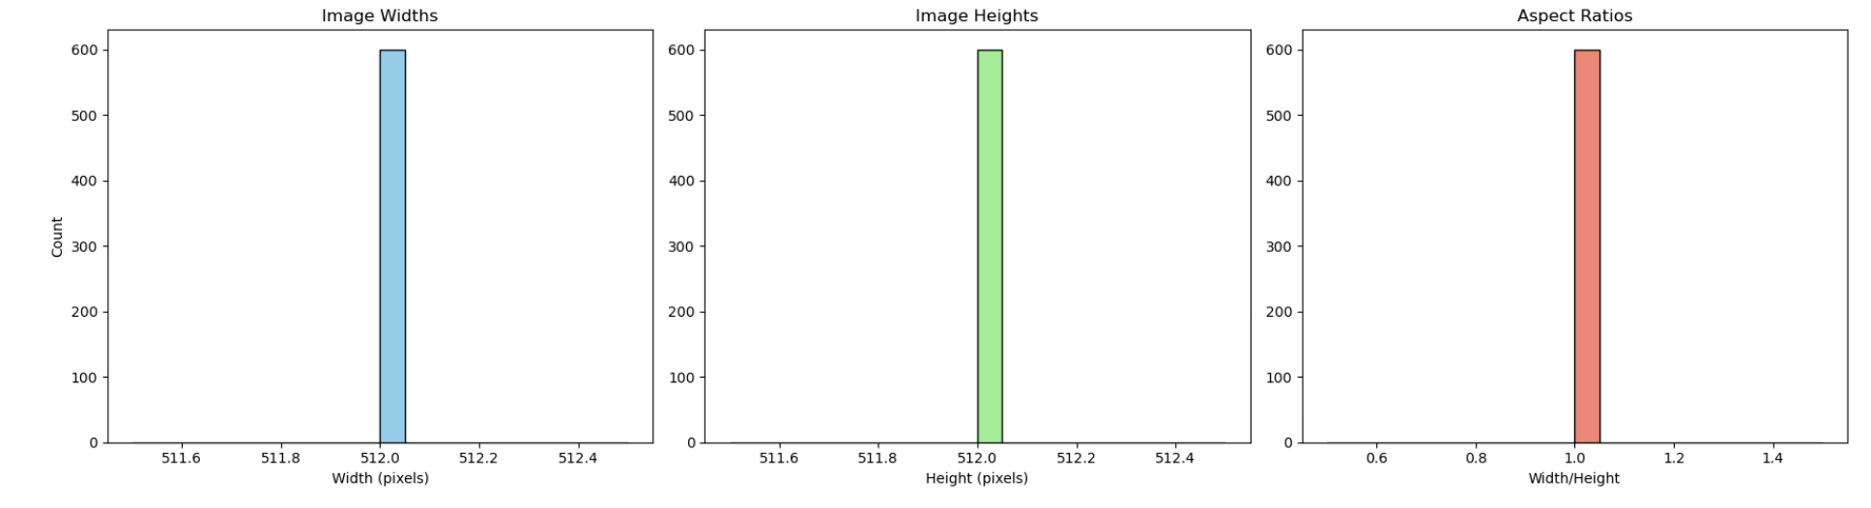

***Figure 2: Image width, height, and aspect ratio distributions***

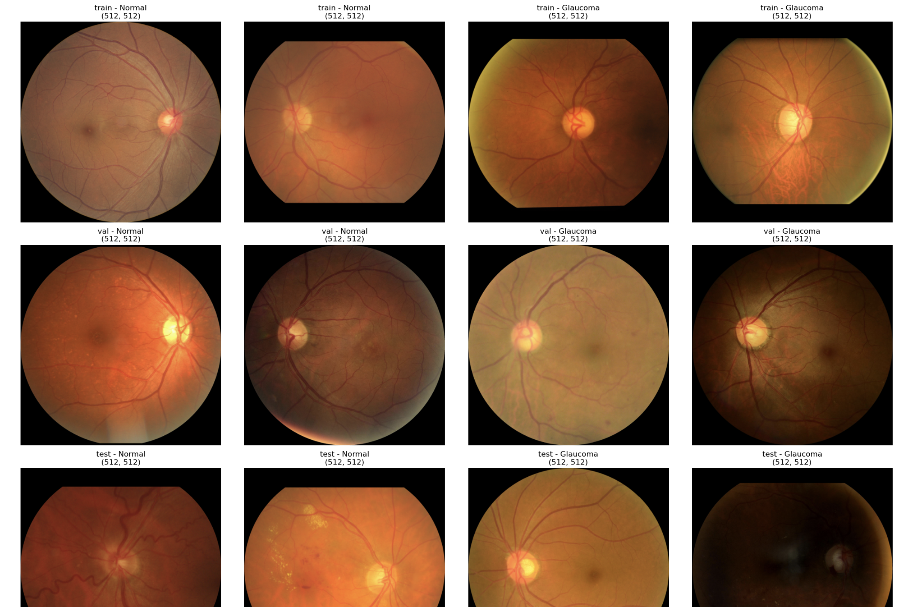  
 ***Figure 3: Sample fundus images across all splits and classes***

## 2.2 Data Preprocessing:

Preprocessing plays a critical role in medical image analysis, especially in tasks like glaucoma detection where subtle patterns in fundus images determine diagnostic outcomes. To improve the signal-to-noise ratio, enhance clinically relevant features, and standardize inputs for the deep learning model, an advanced preprocessing pipeline was developed. Each step was carefully chosen to contribute to improved model performance, faster convergence, and better generalization. The steps are as follows:

1. **Resizing to Standard Input Dimensions (224×224)**: Fundus images from the original dataset had varying dimensions (e.g., 512×512). All images were resized to 224×224 to match the input size expected by the CNN model. These resizing balances computational efficiency and feature preservation.
2. **Normalization**: After resizing, pixel values were normalized from [0, 255] to [0, 1]. This is a common practice in deep learning to stabilize gradients and improve convergence, especially when using activation functions like ReLU.
3. **CLAHE (Contrast Limited Adaptive Histogram Equalization)**: To enhance local contrast in regions like the optic disc and blood vessels, CLAHE was applied to the L-channel of the LAB color space. This step revealed more vascular and structural patterns that are often indicative of glaucomatous changes.
4. **Gamma Correction:** Gamma correction adjusts the luminance of the image by emphasizing mid-tone intensity ranges. A γ value of 1.2 was used to slightly brighten darker regions, improving visibility of subtle textures and features often obscured in standard illumination.
5. **Noise Reduction via Median Blurring** A 3x3 median blur was applied to reduce salt-and-pepper noise without blurring important retinal features. This helps reduce overfitting to random pixel artifacts while maintaining edge sharpness.
6. **Class-Aware Augmentation (Training Only)**: To address class imbalance (Glaucoma ≈ 39%), the training set was augmented more heavily for the minority class. Augmentation included: (1) Random rotations (±20°) (2) Horizontal flipping (3) Brightness and contrast adjustments (4) Random cropping and resizing.

This augmented diversity helps the model become robust to orientation, lighting, and device variations, and encourages better generalization to unseen images.

The following image illustrates each transformation applied to a subset of glaucoma and normal fundus images:

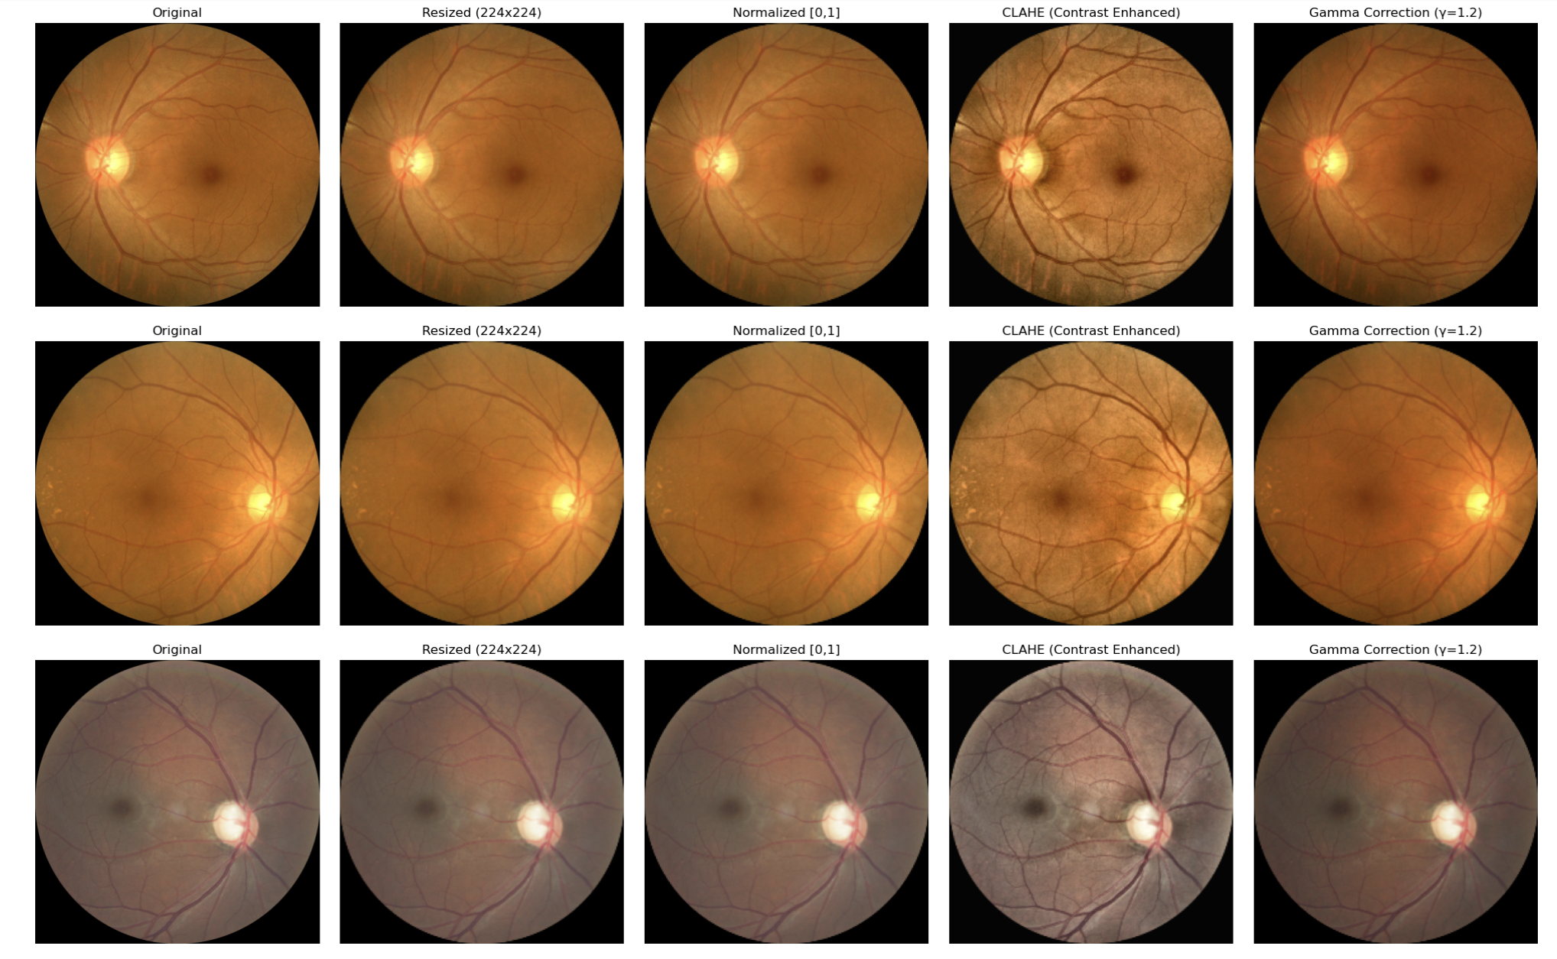

***Figure 4: Preprocessing Pipeline Visualization***  
*(From left to right: Original → Resized → Normalized → CLAHE → Gamma Correction)*  
*Each row corresponds to a different image sample from the dataset.*

After preprocessing, each image was saved as a **.npy** file to enable fast loading and efficient memory management during training. This format ensured seamless integration with PyTorch’s Dataset class and allowed batch processing without the overhead of repeated image transformations.

## 2.3 Model Architecture:

**Model Exploration and Design Evolution:** The model design journey began with experimentation on well-known pre-trained architectures like ResNet50 and EfficientNetB0, using transfer learning. Although they are robust for general computer vision tasks, both models yielded only ~74% training accuracy and plateaued early due to limited domain-specific learning and the high resolution of fundus images. Given the dataset size was under 4GB and manageable in memory, I decided to design a custom CNN model from scratch, allowing full control over how domain-specific features like optic disc structure and vessel patterns were extracted.

Initially, a basic 30-layer CNN was built, achieving ~50% accuracy on the validation set. Through multiple iterations and architectural refinements, the model was gradually scaled to 129 layers with specialized modules that helped boost the accuracy to ~85%.

Medical image analysis presents unique challenges—such as subtle class boundaries, high intra-class variation, and the need for capturing both global and fine-grained features. Standard CNN architectures often fall short in extracting such complex visual patterns. Thus, this project designs a custom deep CNN architecture, named MedicalCNN, that combines several proven architectural elements to boost glaucoma detection performance:

1. **Residual Blocks** – To combat vanishing gradients and allow for deeper feature learning through identity mappings, inspired by He et al.’s ResNet [2].
2. **Squeeze-and-Excitation (SE) Blocks** – To model channel-wise interdependencies and enhance the representational power of feature maps by reweighting channel importance [3].
3. **Multi-Dilated Convolution Block** – To capture multi-scale retinal features (e.g., optic disc size, blood vessel spread) without increasing the kernel size or down sampling, like ideas from atrous spatial pyramid pooling (ASPP) [4].
4. **Deep Fully Connected Head with Dropout** – To ensure robust classification while reducing overfitting, crucial for small medical datasets.

This architecture is designed with a focus on clinical relevance, generalization, and computational efficiency, and is tailored to handle large, high-resolution images like those in the SMDG-19 dataset.

The complete **MedicalCNN** model has:

* **129 layers** in total
* **~22.5 million parameters**
* A combination of:
  + A convolutional stem (Conv → BN → ReLU → MaxPool)
  + 4 sequential residual stages (ResNet-style)
  + A Multi-Dilated Block (capturing multi-scale context)
  + SE attention modules within residual blocks
  + A deep, regularized MLP head with BatchNorm + Dropout
  + Global average pooling before classification

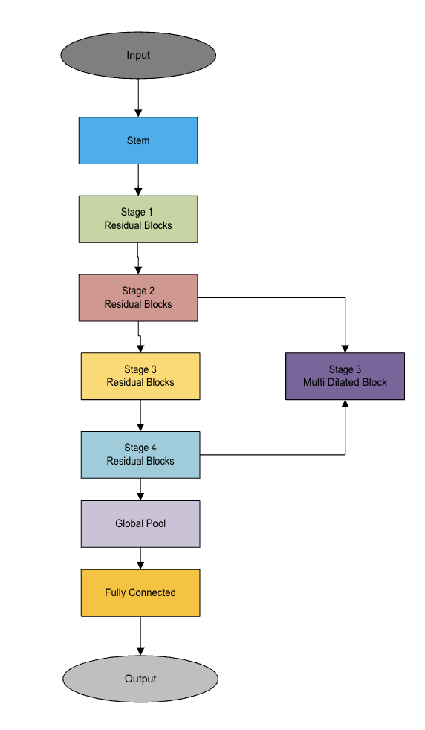

***Figure 5: Medical CNN Model architecture***

## 2.4 Parallelization Techniques:

Training deep convolutional neural networks on high-resolution fundus images is computationally intensive due to the size of the data and depth of the model. The MedicalCNN architecture used in this project contains 129 layers and over 22.5 million parameters, and the dataset comprises 17,000+ images, each processed at 224×224×3 resolution.

Without parallelization:

* Training time becomes a bottleneck. (~12.6 hours for serial training on CPU)
* Resource utilization (especially multi-core CPUs and multi-GPU systems) remains underutilized.
* The model may not scale well when adapting to larger datasets or when increasing architectural complexity.

To address this, we tried implemented the parallel training techniques to distribute the workload, accelerate training, and scale across devices. We tried both **data parallelism** and **model parallelism**. In addition to this we tried implemented Automatic Mixed Precision as well. In Model Parallelism perspective we have tried implemented FSDP (Fully Sharded Data Parallel) as well.

We have experimented below parallelization techniques as part of this project:

1. DDP to train model on CPUs [2,4,8,16,24,32]
2. DDP to train model on GPUs [2,4]
3. DDP + AMP to train.
4. DDP + AMP + Model Parallel.

Now we will discuss how each technique was used in the project in more detail.

### **2.4.1 Distributed Data Parallel on CPUs and GPUs:**

Training a deep convolutional neural network like MedicalCNN on over 17,000 preprocessed fundus images can take several hours or even days on a single CPU core. To accelerate the training process while utilizing computational resources efficiently, Distributed Data Parallelism (DDP) on multiple CPU processes was employed. PyTorch’s DDP framework allows us to spawn parallel training processes across CPU/GPU cores. Each process is assigned a subset of the dataset, with gradients averaged across processes during backpropagation. This setup ensures that the model converges identically to a single-process setup but significantly faster.

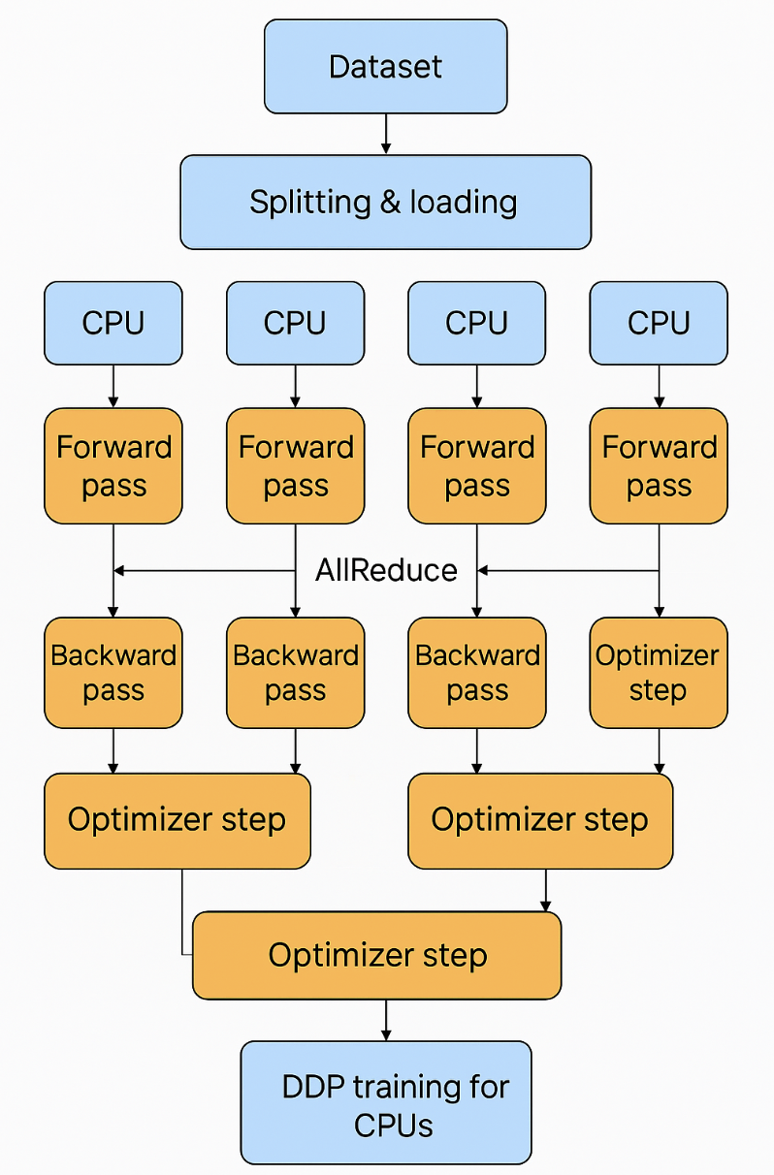

***Figure 6: Overview DDP Training on 4 CPUs***

Considering the technique it’s the same for both GPU and CPU – only the underlying machine and the backend changes. To scale model training across multiple CPU cores and ensure efficient utilization of compute resources, PyTorch’s DistributedDataParallel (DDP) was adopted with a well-structured pipeline. The setup ensures synchronized gradient updates across processes and consistent model convergence.

**2.4.1.1 Distributed Initialization:**  
Each process is initialized with a unique rank using torch.distributed.init_process_group() with the **gloo** backend for CPU and **‘nccl’** for GPU. Environment variables like MASTER_ADDR, MASTER_PORT, and WORLD_SIZE are set to coordinate inter-process communication.

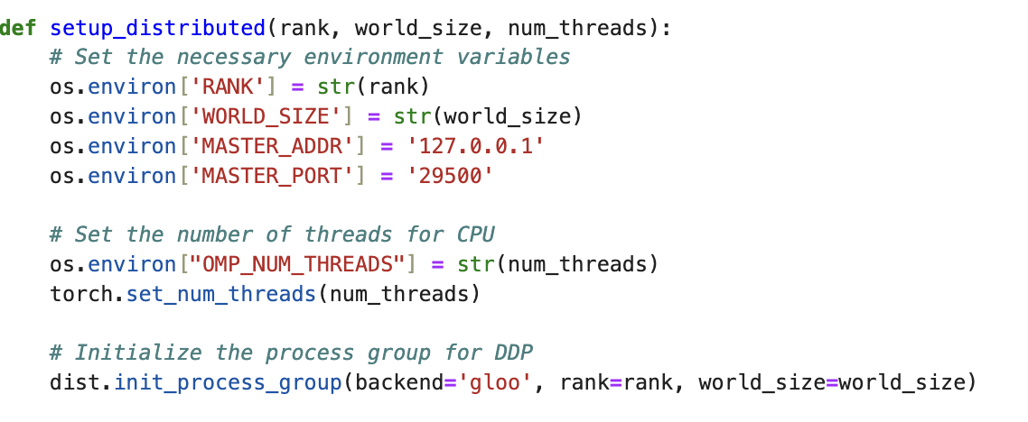

**2.4.1.2 Data Loaders:**  
Preprocessed fundus images and labels are loaded from .npy files into GlaucomaDataset instances. DistributedSampler ensures that each process receives a unique, non-overlapping partition of the data, maintaining class distribution during training and evaluation.

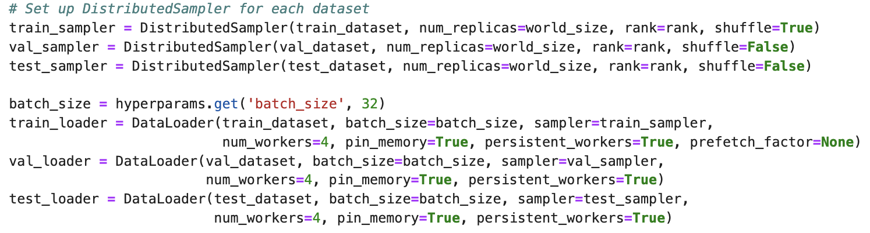

**2.4.1.3 Model Instantiation & Wrapping with DDP:**  
A custom MedicalCNN architecture is initialized per process. It is wrapped with DistributedDataParallel to enable synchronized gradient reduction during backpropagation.

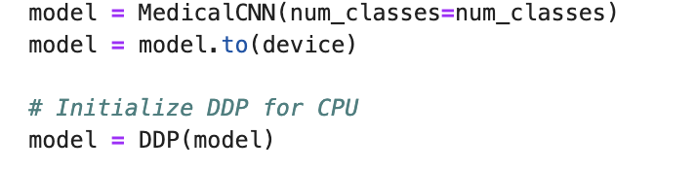

**2.4.1.4 Training Loop:** For each epoch:

* The DistributedSampler is reseeded using set_epoch(epoch) for effective shuffling.
* The forward pass is computed on the local batch, followed by cross-entropy loss computation.
* Gradients are computed using .backward(), during which DDP synchronizes gradients across all processes.
* Gradient clipping (clip_grad_norm_) is applied to prevent exploding gradients.
* The optimizer performs a parameter update, and learning rate is scheduled using cosine annealing.

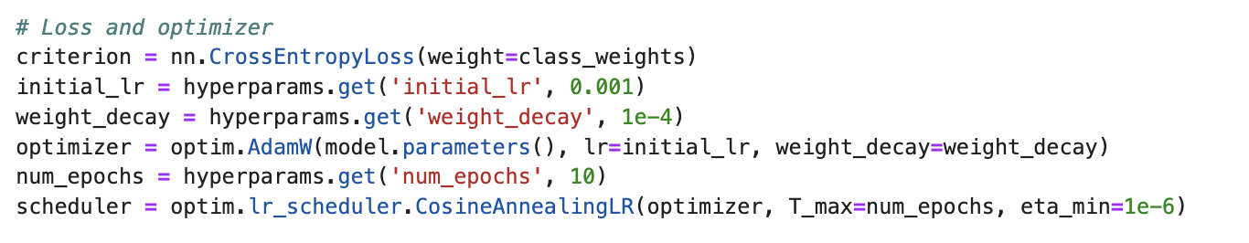

* + - 1. **Execution of Multiple Process:**

Initially, I experimented with using torch.multiprocessing.spawn to launch multiple training processes for DistributedDataParallel (DDP). However, during testing, this approach frequently ran into issues such as “connection closed” errors and inconsistent behavior during process group initialization – particularly on multi-CPUs systems and when debugging failures.

To ensure greater control and stability, I transitioned to using torch.multiprocessing.Process, which allowed me to manually create and manage each process in a clean and predictable manner. This method provided better logging granularity, error handling, and was overall more robust for the parallel training setup.

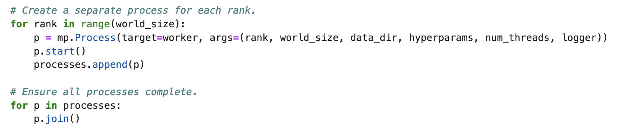

Using DDP across CPUs led to:

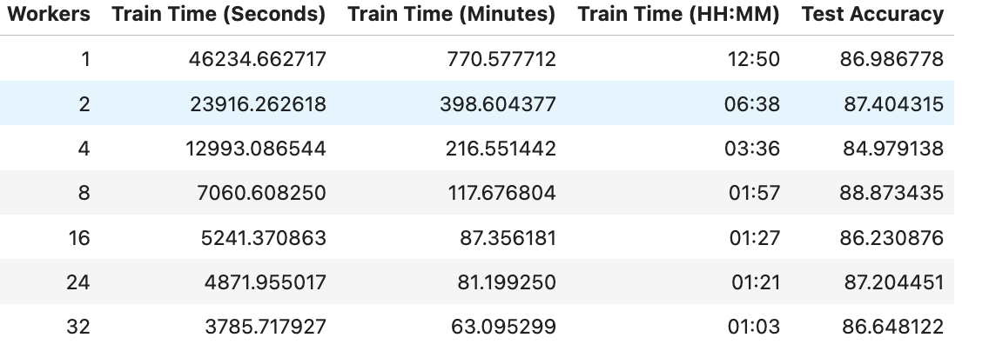

We will compare more on the timings and performance in section 3.

### **2.4.2 DDP + AMP on GPU:**

To accelerate training and reduce GPU memory consumption, Automatic Mixed Precision (AMP) was integrated into the DistributedDataParallel (DDP) setup. AMP enables the model to perform computations in half-precision (FP16) where safe, while maintaining full precision (FP32) for sensitive operations like loss computation and gradient updates. This significantly speeds up training and allows for larger batch sizes without compromising model stability or accuracy.

Within the DDP setup, each GPU process runs independently, handling its own copy of the model and batch of data. AMP operates locally within each process, using **torch.cuda.amp.autocast()** for mixed-precision inference and **GradScaler** to prevent numerical instability during backpropagation. Once gradients are computed locally, DDP automatically synchronizes them across all GPUs during the backward pass. Since AMP acts before synchronization, it integrates seamlessly with DDP without introducing any inter-process conflicts.

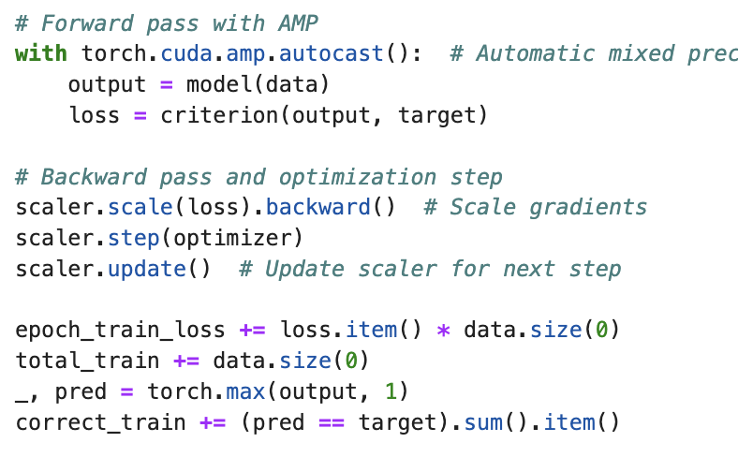

### **2.4.3 DDP + AMP + Model Parallel on GPU**

To maximize hardware utilization and accelerate training of the deep MedicalCNN architecture, we have implemented a powerful combined strategy in this project: Distributed Data Parallel (DDP) + Automatic Mixed Precision (AMP) + Model Parallelism.

The custom MedicalCNN architecture is deep (129+ layers) and contains over 22 million parameters. When using high-resolution fundus images with large batch sizes, memory pressure on a single GPU becomes significant. While DDP distributes data across multiple GPUs, model parallelism further divides the model itself, assigning different parts of the network to different GPUs. This reduces memory usage on each device and allows training of larger models without OOM (Out of Memory) errors.

In this project, the model layers are manually partitioned across two GPUs (cuda:0 and cuda:1). This is achieved by assigning the following stages to different devices during model initialization:

|  |  |
| --- | --- |
| **GPU** | **Assigned Layer** |
| Cuda:0 | Stem, Stage 2, Stage 4, Global Average Pooling, FC Head |
| Cuda:1 | Stage 1, Stage 3 (Residual + MultiDilated Blocks) |

Each block is explicitly constructed on its corresponding device using .to(device) during model initialization. This allows the forward pass to span across devices seamlessly and ensures that memory and compute are balanced between them.

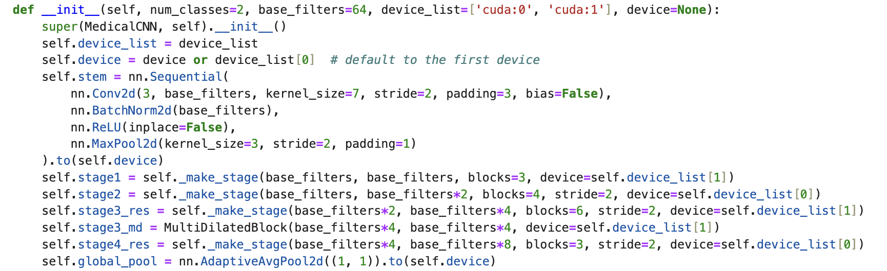

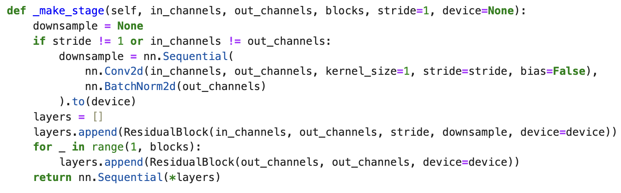

# Result and Analysis

## 3.1 Selecting Right Batch Size

Batch size significantly influences the training dynamics of deep neural networks, especially with high-resolution medical images. To determine the most efficient configuration for our MedicalCNN model, I conducted serial training (non-parallel) on a single GPU across three batch sizes: 16, 32, and 64.

|  |  |
| --- | --- |
| **Batch Size** | **Training Time (in minutes)** |
| 16 | 9.84 mins |
| 32 | 8.5 mins |
| 64 | 7.8 mins |

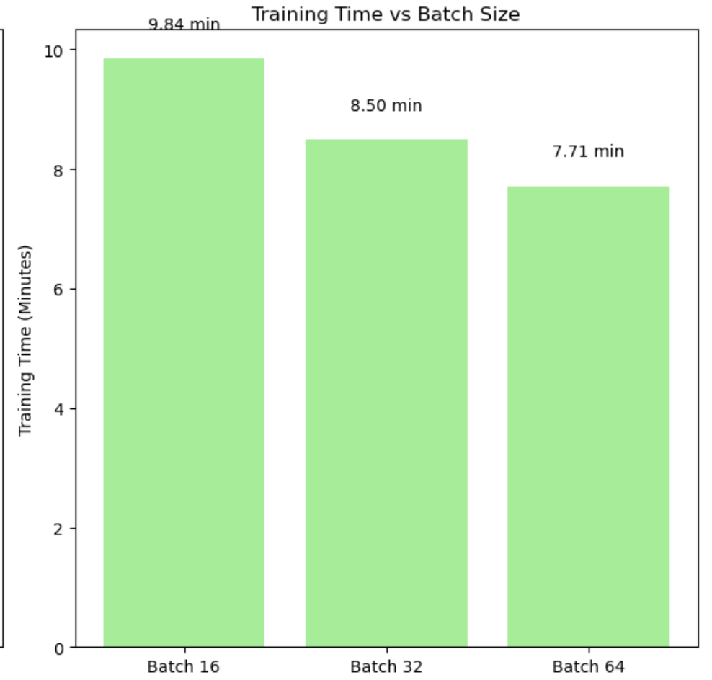

**Figure 7: Training Time details for different batches**

The chart (Figure 7) compares training times for three batch sizes - 16, 32, and 64 - on GPU with serial execution. While batch size 64 offers the shortest training time (7.71 minutes), deploying it in a multi-GPU setup with DDP introduced performance bottlenecks. The large batch size significantly increased the volume of data shuffling between GPU workers, causing **slower epoch transitions and communication overhead** due to heavy **inter-process data transfer**.

After observing this behavior, I switched to batch size 32, which not only maintained high test accuracy (86.85%), but also ensured smoother performance and better load distribution across devices in the DDP pipeline—thus becoming the final chosen batch size for multi-GPU experiments.

## 3.2 Accuracy check

To understand how batch size influences model performance, I evaluated the test accuracy for three different batch sizes - 16, 32, and 64 - during GPU serial training. The results are shown in Figure 8.

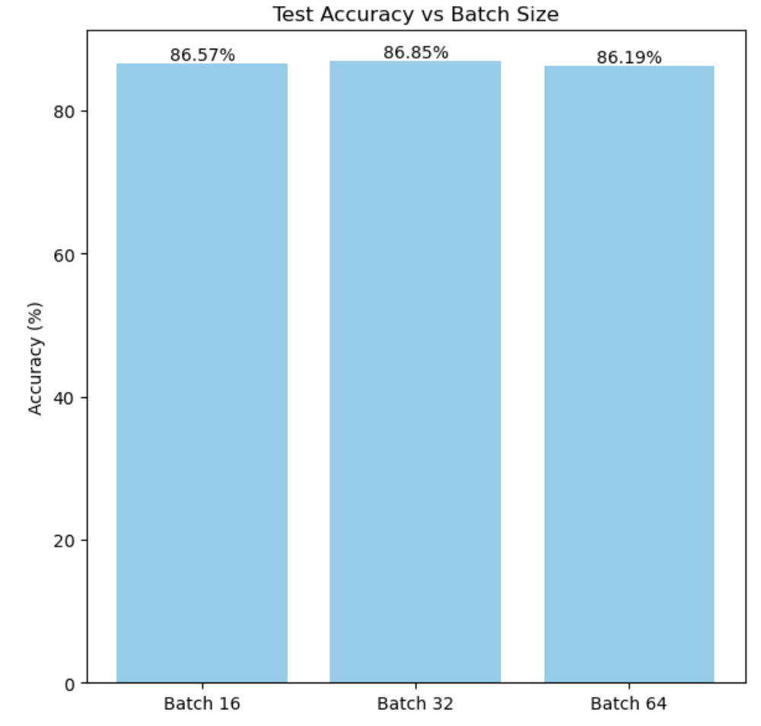

**Figure8: Accuracy across batch sizes**

* **Batch 16**: 86.57%
* **Batch 32**: **86.85%**
* **Batch 64**: 86.19%

The accuracy across batch sizes showed minimal variation, which is expected due to the dataset's size and model generalization. Despite the similar accuracy values, batch size 32 slightly outperformed the others. Therefore, batch size 32 was selected along with its ability to prevent delays due to data transfer overhead and a good balance between computational efficiency and model performance.

After selecting **batch size 32**, I examined how the number of parallel workers (CPUs) impacts test accuracy under a DDP CPU setup. The number of processes (or workers) varied from 1 to 32. The results are illustrated in Figure 9.

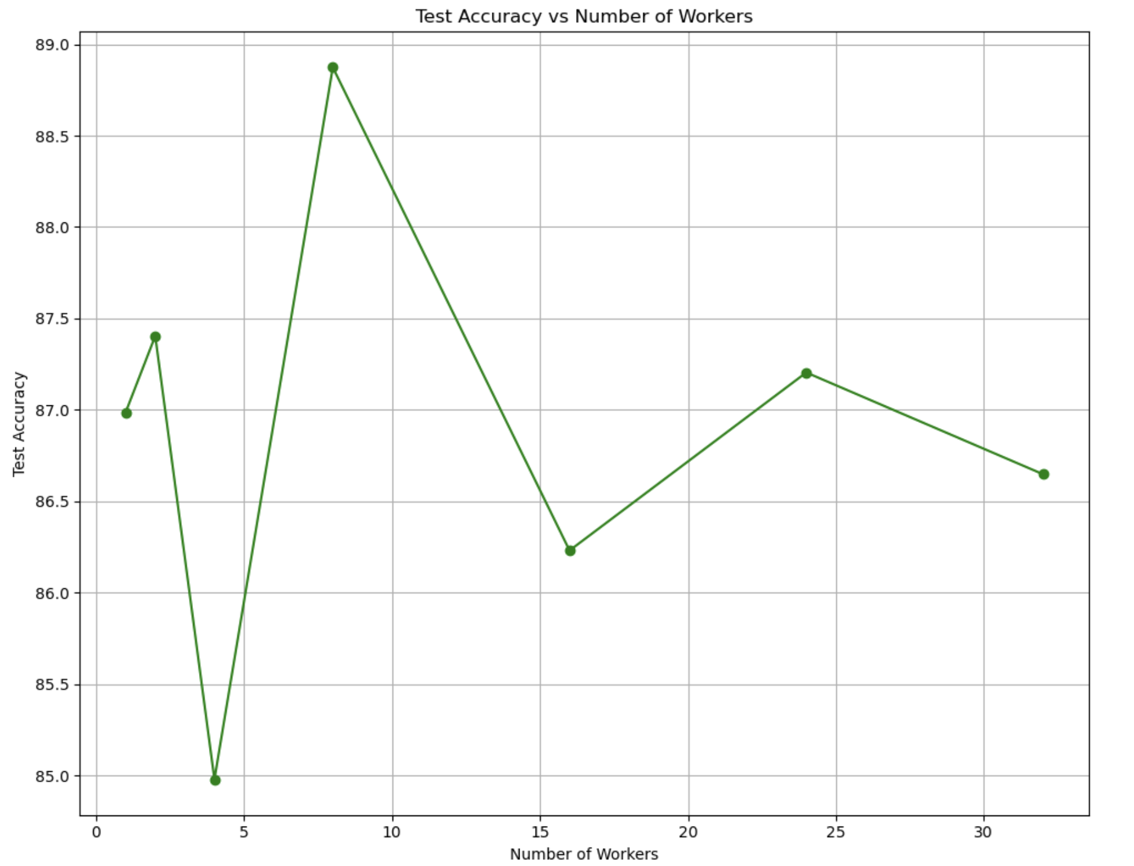

**Figure 9: Number of Works VS Test Accuracy**

The key observations are:

* The highest accuracy of 88.9% was achieved with 8 workers.
* Accuracy fluctuated slightly beyond 8 workers, likely due to increased communication overhead or suboptimal batch splitting as the process count increases.
* Extremely low worker counts (like 4) underperformed, with 85% accuracy, possibly due to insufficient parallel gradient updates and underutilized cores.

These findings emphasize that increasing workers does not linearly improve accuracy, and an optimal number of processes (around 8) can provide better generalization by enabling diverse data processing across batches.

## 3.3 Training on Single vs Multiple CPUs

To evaluate the scalability of my pipeline, I compared single CPU training against multi-process CPU training using Distributed Data Parallel (DDP). These experiments were conducted on the **d0010 node** of the cluster, with configuration of **32 CPU cores** and **50 GB memory.** This allowed me to test configurations ranging from 1 to 32 parallel workers for distributed training.

To further optimize training speed, I fine-tuned the DataLoader settings:

* **num_workers=4**: Each process was configured with multiple subprocesses to load data in parallel. Increasing this helps reduce the time spent waiting for data I/O.
* **persistent_workers=True**: Keeps the workers alive across epochs instead of shutting them down and restarting, minimizing setup overhead.
* **prefetch_factor=2**: Allows each worker to pre-load two batches, ensuring that data is readily available and preventing the GPU/CPU from idling.

These optimizations significantly reduced data loading bottlenecks (previously it was taking at least 15-20mins additionally), making the pipeline more efficient, especially when scaled across multiple processes. When combined with DDP, they allowed for seamless scaling on CPU-only environments.

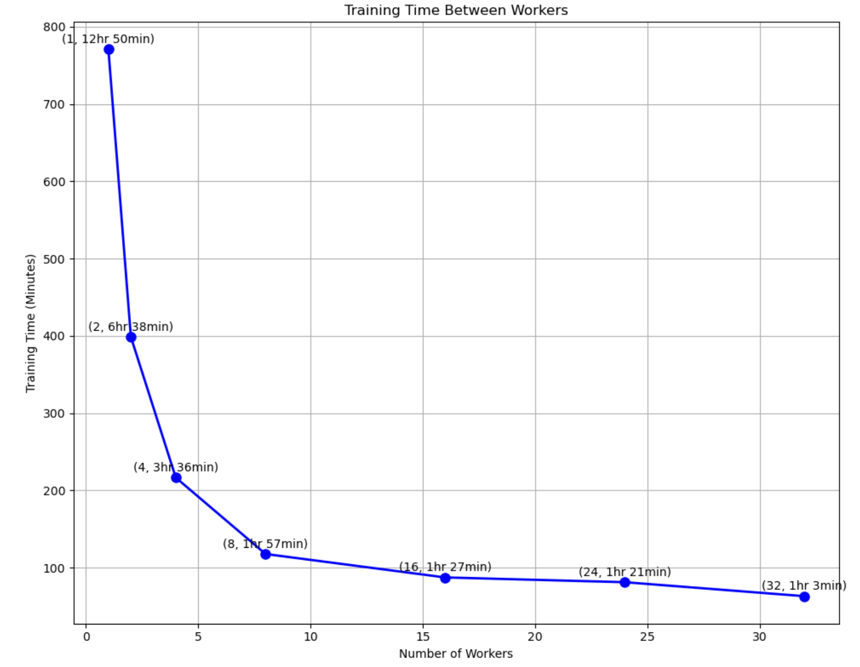

**Figure 10: Training time across workers**

The results are illustrated in Figure 10, which shows a steep reduction in training time as the number of workers increases:

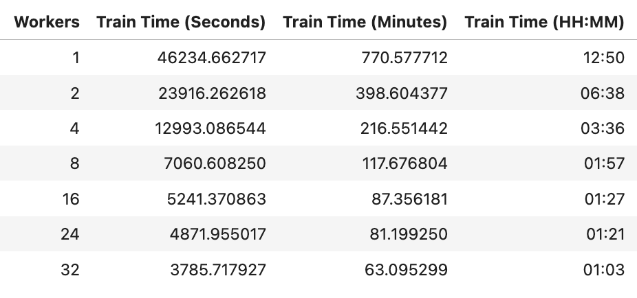

This demonstrates a nearly 12x speedup from 1 to 32 workers, though with diminishing returns at higher worker counts due to overhead and communication costs.

### 3.3.1 Speedup

To quantify the performance gains achieved through parallelism, I computed the speedup of training as the number of CPU workers increased. Speedup is calculated as:

Speedup = Train time in Serial Execution / Train time in Parallel Execution.

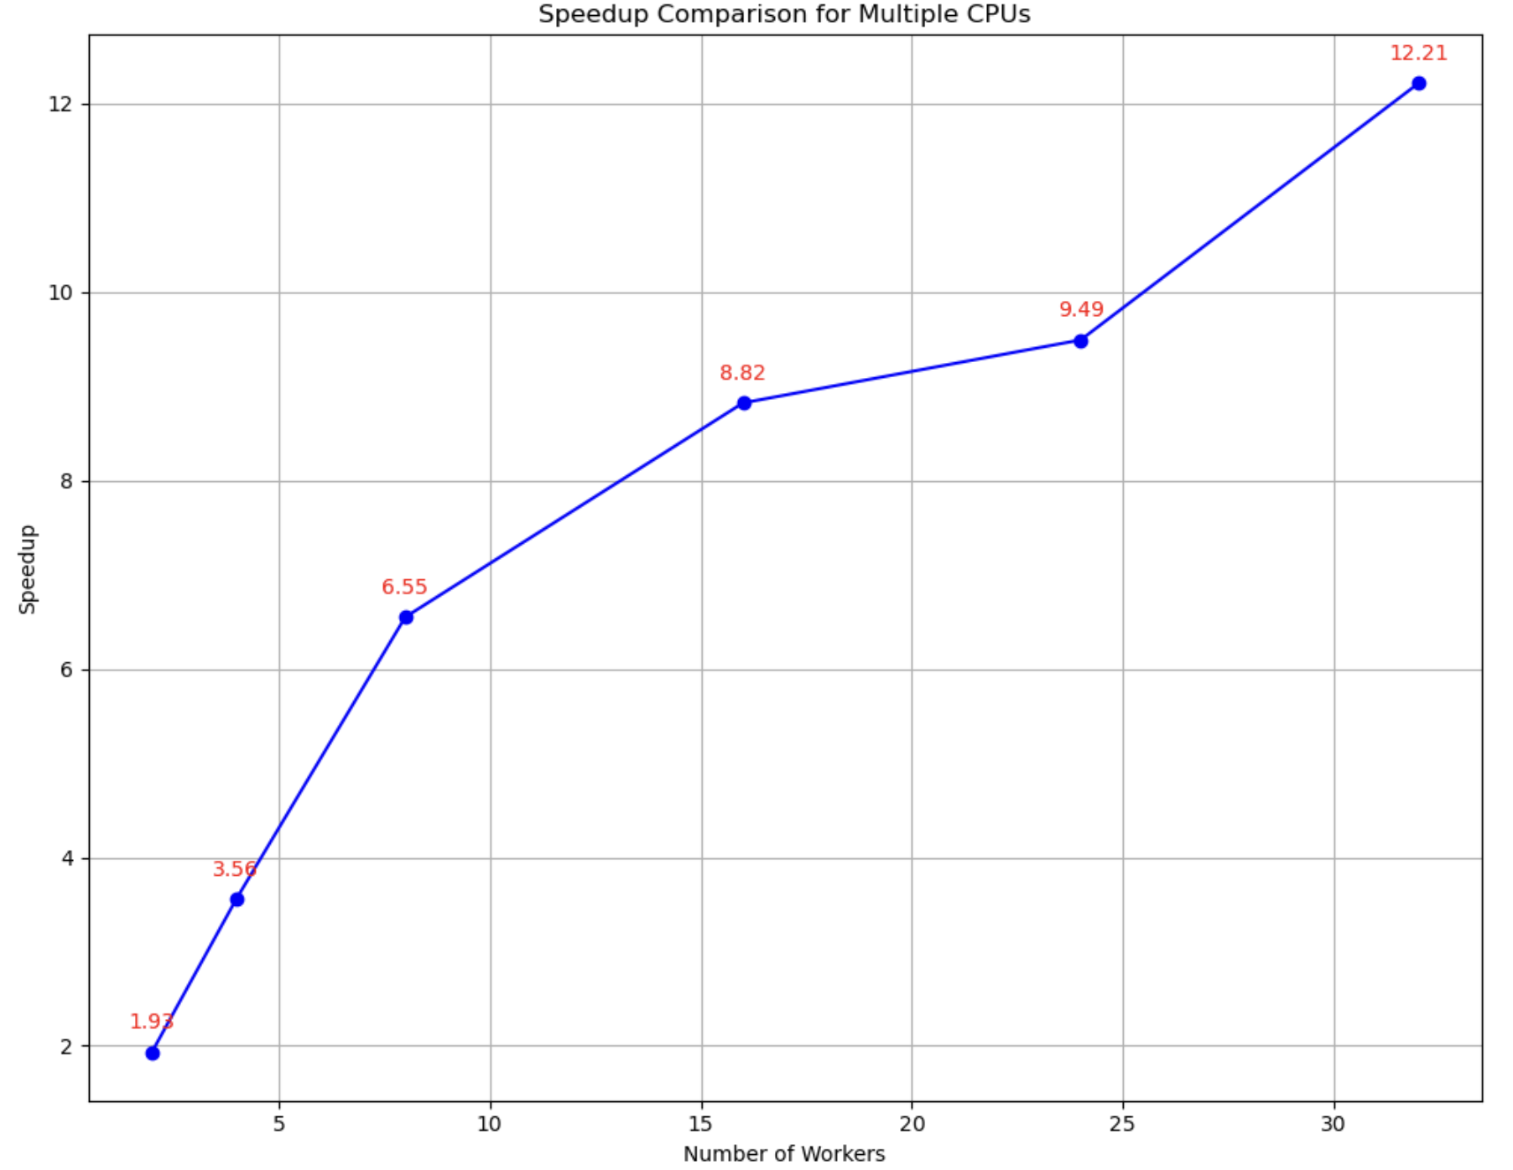

**Figure 11: Number of workers vs Speedup**

The results are visualized in Figure 11, which shows the speedup trend for 2, 4, 8, 16, 24, and 32 workers.

This demonstrates that DDP scales efficiently with CPU workers, achieving over 12x speedup with 32 processes compared to serial execution. However, as expected, the speedup curve begins to flatten beyond 16 workers due to overhead from process coordination, synchronization, and data shuffling.

While linear speedup is ideal, real-world training incurs some overhead. Still, this level of improvement validates the effectiveness of the DistributedDataParallel + optimized DataLoader strategy for training deep learning models in CPU-only environments.

### 3.3.2 Efficiency

While increasing the number of workers significantly reduces the training time, as evidenced by the speedup graph, the efficiency graph reveals a trade-off. Initially, with 2 and 4 workers, the efficiency remains high (0.97 and 0.89 respectively), indicating near-ideal parallelism where most CPU resources are effectively utilized.

However, as the number of workers increases, the efficiency gradually declines:

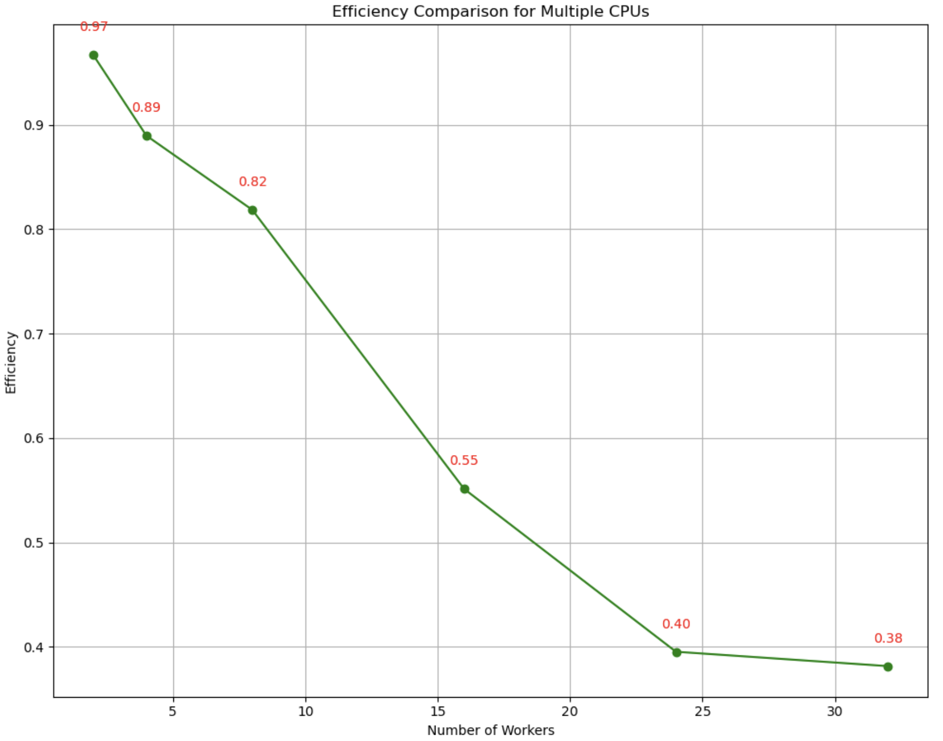

**Figure 12: Number of workers vs Efficiency**

This decline is primarily due to the increased communication and synchronization overhead between processes, especially with higher worker counts. Beyond a certain point, the diminishing returns of adding more workers start to outweigh the speed benefits.

Taking both training time and efficiency into account, the optimal configuration lies between 8 and 16 workers. These configurations provide substantial speedup while maintaining a balanced efficiency, avoiding excessive overhead.

## 3.4 Training on GPUs

To evaluate how hardware configuration affects training performance, I experimented with three GPU configurations (in serial execution)**: P100, V100 SXM-2, and V100 SXM-2** **with AMP**. The goal was to assess both raw GPU speed and the potential acceleration achieved by enabling AMP.

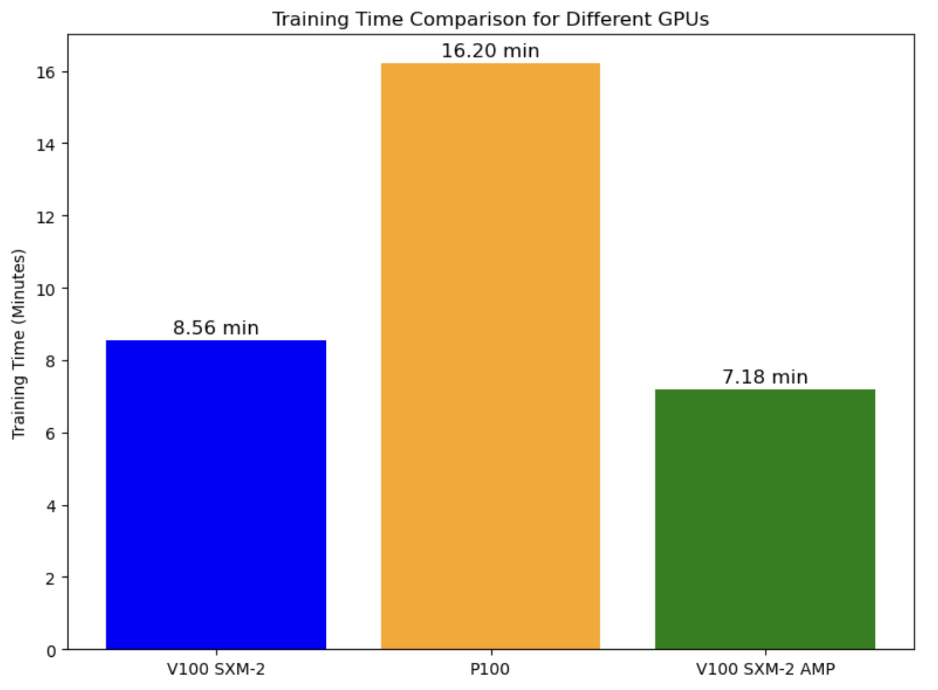

**Figure 13: Different GPUs vs Serial training time**

The P100 GPU, being an older architecture, recorded the slowest training time. Switching to the V100 SXM-2, which has significantly better memory bandwidth and computational power, halved the training time. This demonstrates how much newer GPU architectures can improve training efficiency.

Furthermore, enabling AMP on the V100 SXM-2 reduced the training time even further **to 7.18 minutes.** AMP leverages mixed-precision training**,** using half-precision floating-point arithmetic where possible, which reduces memory usage and accelerates tensor operations - particularly beneficial on Tensor Core-enabled GPUs like the V100.

## 3.5 Multiple GPUs Performance:

### 3.5.1 With DDP:

To accelerate parallel training, I utilized Distributed Data Parallel (DDP) on **both V100 SXM-2 and P100 GPUs**, evaluating performance across **1, 2, and 4** GPU configurations (more configurations weren’t allowed in the cluster). As illustrated in Figure 14, training time consistently decreased with the addition of more GPUs.

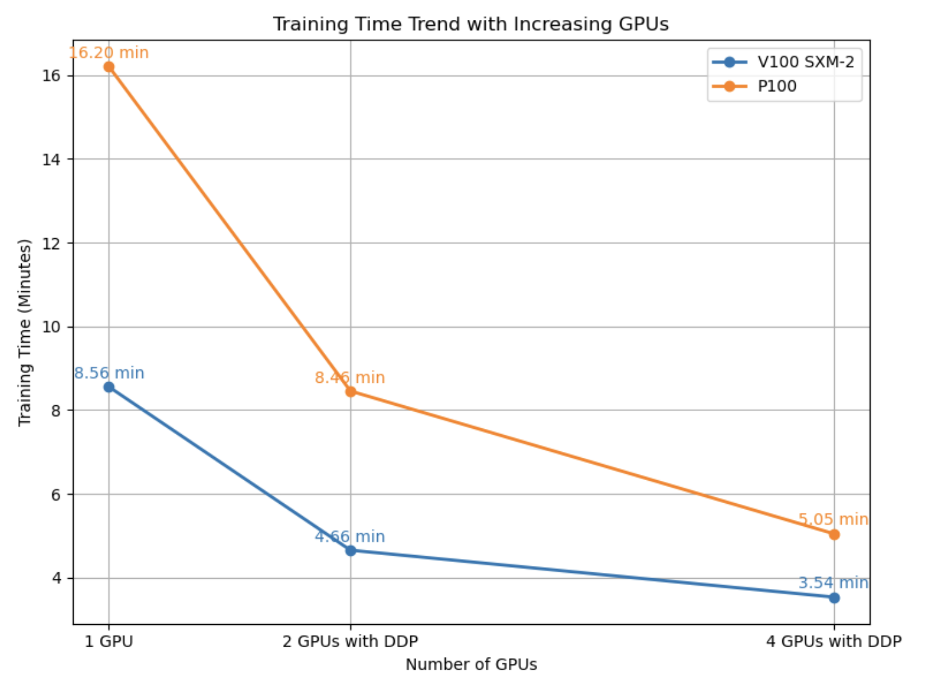

**Figure 14: Number of GPUs vs Training Time**

While DDP effectively reduced training time, I observed diminishing returns beyond 2 GPUs. Given that my dataset is approximately 4GB, a 2-GPU setup is optimal - it balances computational efficiency without introducing excessive overhead. The use of 4 GPUs exceeded the memory and processing requirements for my model and dataset, leading to marginal gains in performance while increasing communication costs between devices.

Thus, for this project, 2 GPUs provide the best trade-off between training speed and resource efficiency. Let’s discuss about this in detail in speedup and efficiency section.

**3.5.1.1 Speedup & Efficiency:**

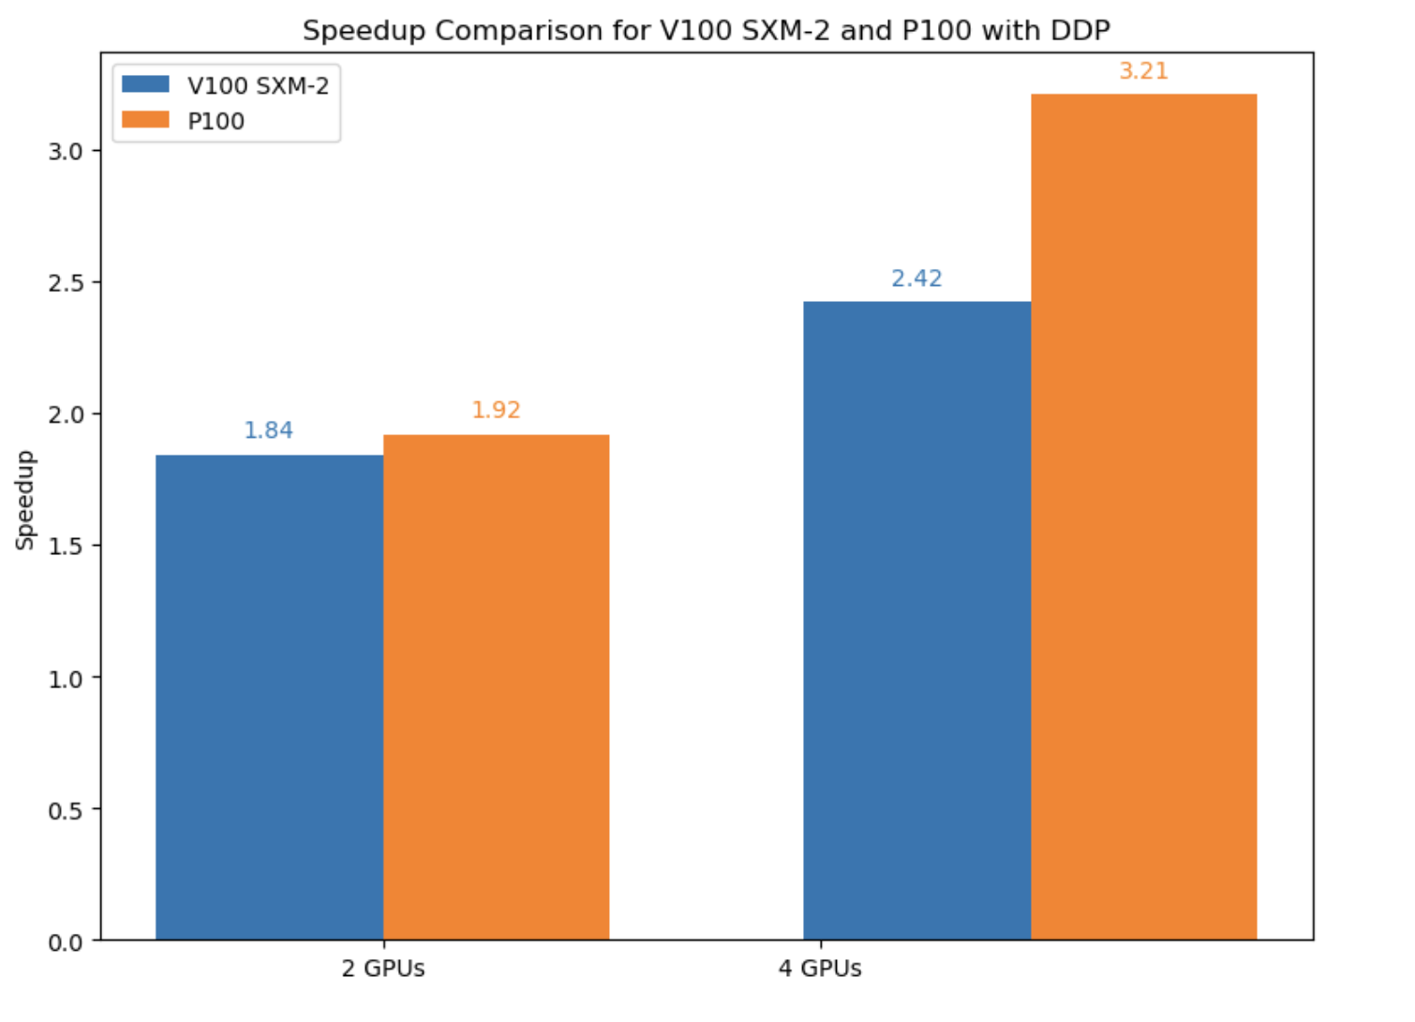 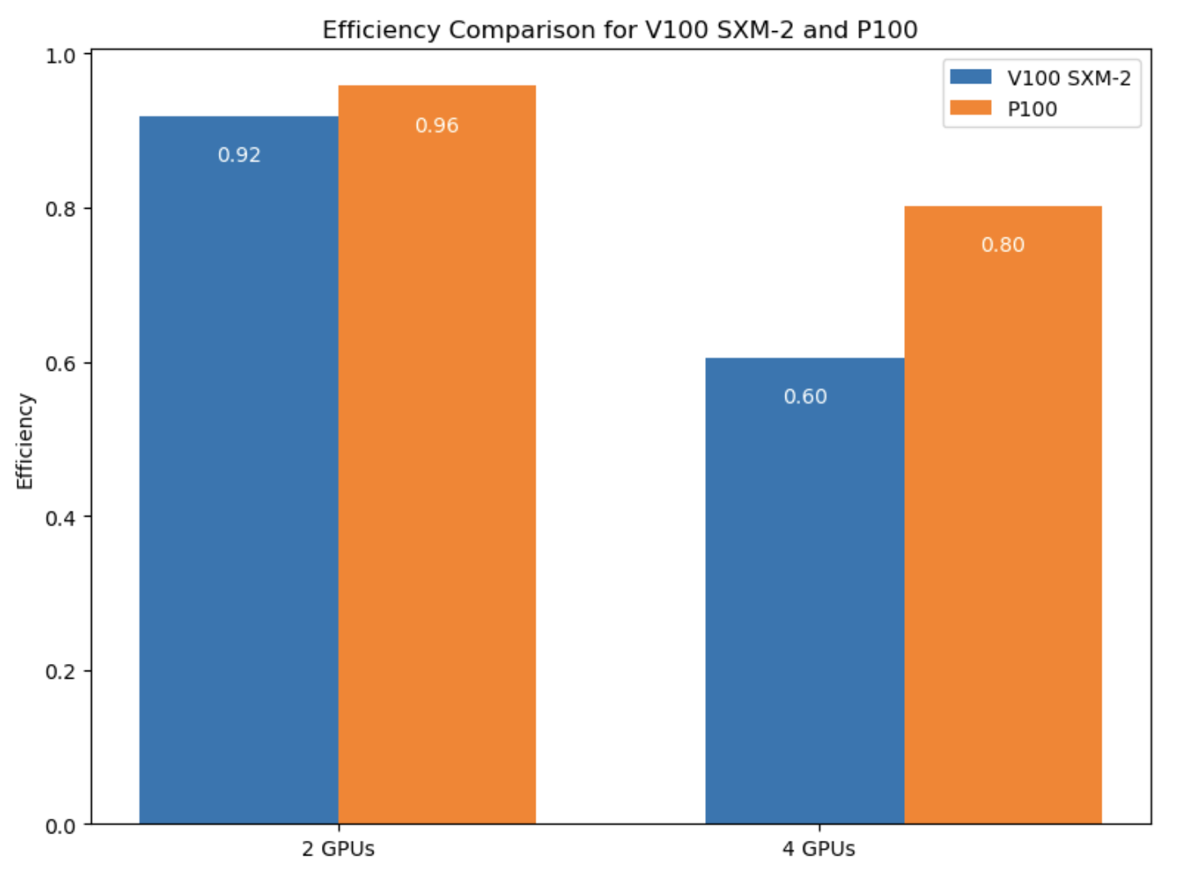

**Figure 15 : Speedup and Efficiency with DDP -2,4 GPUs**

To further evaluate GPU performance, I compared speedup and efficiency when using 2 and 4 GPUs on both V100 SXM-2 and P100 architectures. While P100 GPUs showed slightly higher speedup and efficiency values, the overall training time was significantly better with V100 SXM-2.

Despite the marginally higher speedup/efficiency on P100s, the raw training time for V100 SXM-2 remained significantly lower across all GPU counts. This is primarily due to V100’s newer architecture and faster memory bandwidth, which helps reduce computation time. While P100 appears more efficient on paper, V100 SXM-2 offers the best practical performance for my training workload, especially given the smaller dataset (~4GB). Based on these insights, 2 V100 GPUs with DDP struck the best balance between performance, training time, and system utilization.

### 3.5.2 With DDP + AMP:

**3.5.2.1 Training Time:**

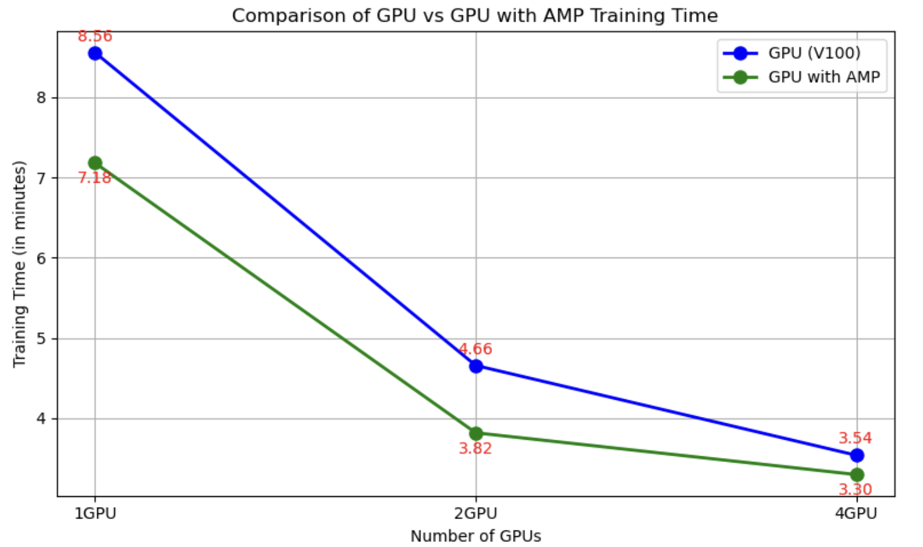

**Figure 16: Number of GPUs VS Training Time**

As observed in the Figure 16 comparing V100 and V100 with AMP across 1, 2, and 4 GPUs, AMP significantly reduces the training time when compared to running on standard GPU configurations.

* For 1 GPU, the training time with V100 was 8.56 minutes, while the same configuration using AMP took just 7.18 minutes. This indicates a clear improvement in training speed, with AMP providing a reduction of about 1.38 minutes.
* For 2 GPUs, the training time dropped from 4.66 minutes (V100) to 3.82 minutes (V100 with AMP). AMP led to a performance gain of 0.84 minutes, which is more noticeable as the number of GPUs increases.
* For 4 GPUs, the training time for V100 was 3.54 minutes, whereas using AMP reduced it further to 3.30 minutes, which is a 0.24-minute improvement.

Overall, AMP consistently reduced training time across all configurations, with the most substantial improvement observed with 1 GPU, where the reduction was over 1 minute. As the number of GPUs increased, the improvements remained noticeable, but the marginal gain reduced slightly.

**3.5.2.2 Speedup and Efficiency**

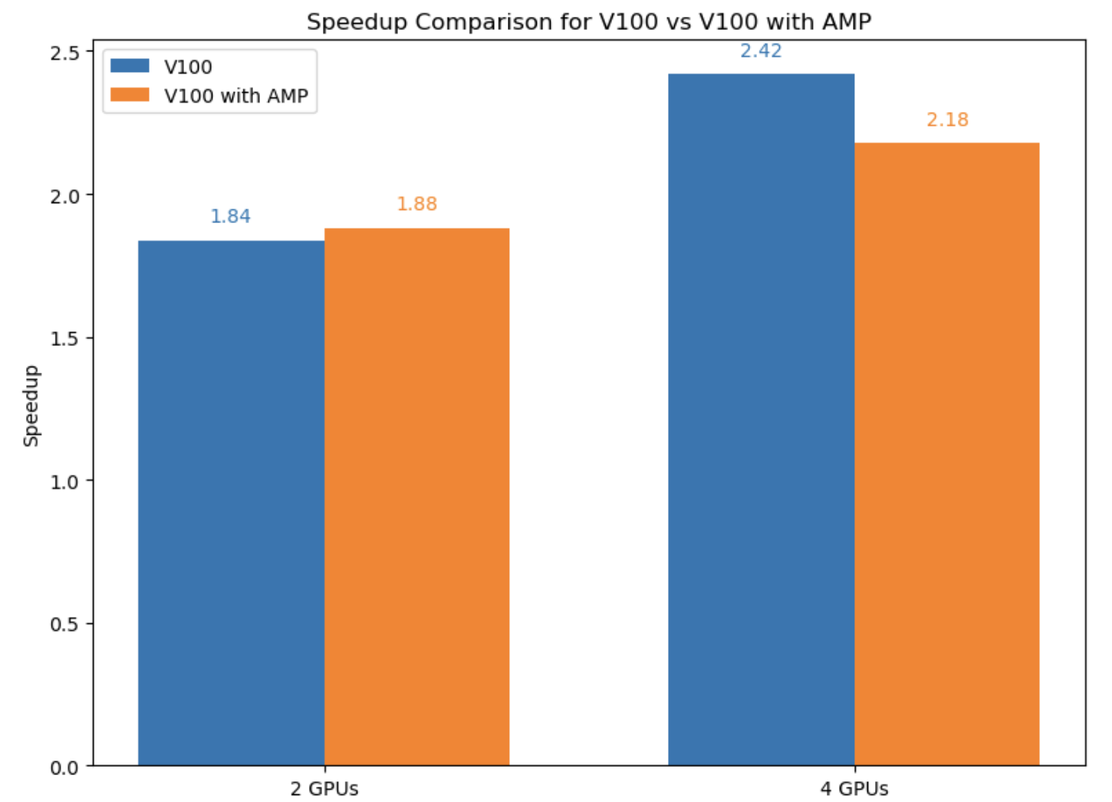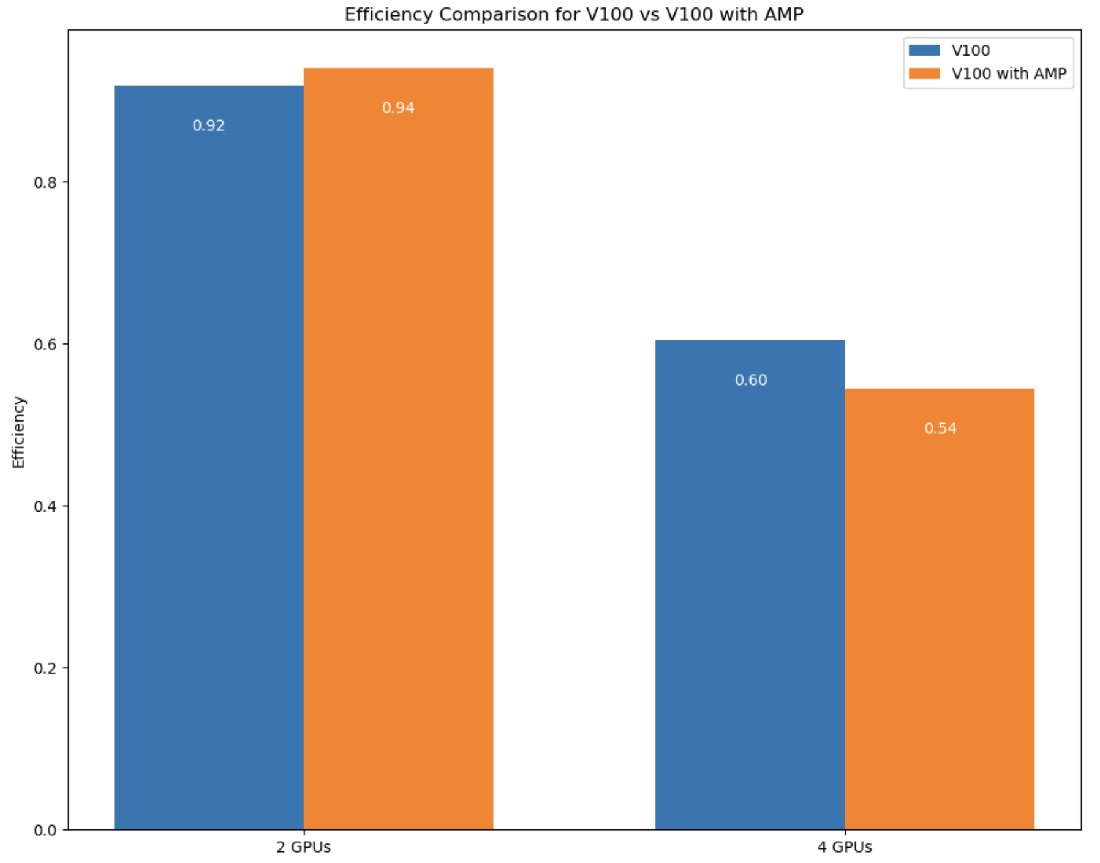

**Figure 17 : Speedup and Efficiency comparison for GPU vs GPU with AMP**

Using DDP with AMP provides a significant boost in performance, particularly when scaling across multiple GPUs. The speedup achieved with AMP-enabled training shows noticeable improvements in efficiency and reduces training time, especially when using 2 GPUs. With AMP, training on 2 GPUs resulted in a speedup of 2x over the single GPU configuration, with training times dropping from 8.56 minutes to 4.66 minutes. This makes AMP a valuable tool for optimizing training time without sacrificing model accuracy or introducing significant overhead. The reduced training time with AMP also highlights its impact on making large-scale training more efficient.

However, as the number of GPUs increases, particularly with 4 GPUs, the efficiency starts to diminish slightly, and the speedup becomes less pronounced. In fact, while AMP on 4 GPUs resulted in a speedup of 2.42x (training time reduced to 3.54 minutes), the performance gains were less significant compared to the 2 GPU setup, where the speedup was 2.42x. Despite this, DDP with AMP still outperforms non-AMP configurations, suggesting that for setups involving a limited number of GPUs, AMP provides optimal results. For larger multi-GPU setups, although the speedup from AMP is less significant, DDP with AMP remains a viable option for reducing training time, particularly for medium-sized datasets or models that can fully utilize the parallelism without experiencing communication bottlenecks.

### 3.5.3 With DDP + AMP + Model Parallel:

**3.5.3.1 Training Time:**

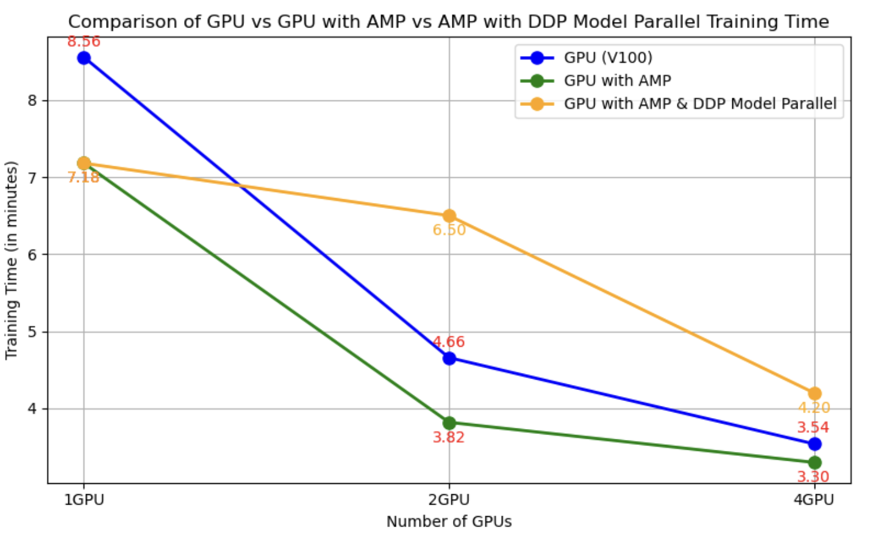

**Figure 18: Comparision between DDP vs DDP+AMP vs DDP+AMP+Model Parallel**

The DDP + AMP + Model Parallel configuration runs at 6.50 minutes for 2 GPUs, which is slower than DDP + AMP alone, which runs at 4.66 minutes. As for 4 GPUs, DDP + AMP + Model Parallel runs at 4.20 minutes, while DDP + AMP runs at 3.54 minutes.

This indicates that while Model Parallel does help with splitting the model across GPUs, it introduces some overhead due to the additional complexity involved in splitting and synchronizing the model's parameters. Given the performance results, the trend suggests that Model Parallel is not necessary for this project, as the model fits well on a single GPU and the DDP + AMP configuration already delivers excellent performance. DDP + AMP is sufficient for optimizing training time without the added complexity of model parallelization.

**3.5.3.2 Speedup and Efficiency:**

For the final analysis, the speedup and efficiency comparisons between V100, V100 with AMP, and V100 with AMP and Model Parallel across different GPU configurations (2 and 4 GPUs) - In terms of speedup, V100 with AMP achieves the highest performance across both 2 and 4 GPUs, as shown by its superior speedup values of 2.42 for 2 GPUs and 2.18 for 4 GPUs, compared to the baseline V100's 1.84 and 1.88, respectively. However, when comparing V100 with AMP and Model Parallel, the speedup decreases significantly (1.39 for 2 GPUs and 1.75 for 4 GPUs). Despite these results, it is essential to keep in mind that the trade-off between speedup and efficiency must be considered. While Model Parallel might seem to slow down the training speed, the parallelism benefits it offers in distributing model parts across multiple GPUs could be valuable for larger models, but this is not necessary for this specific project.

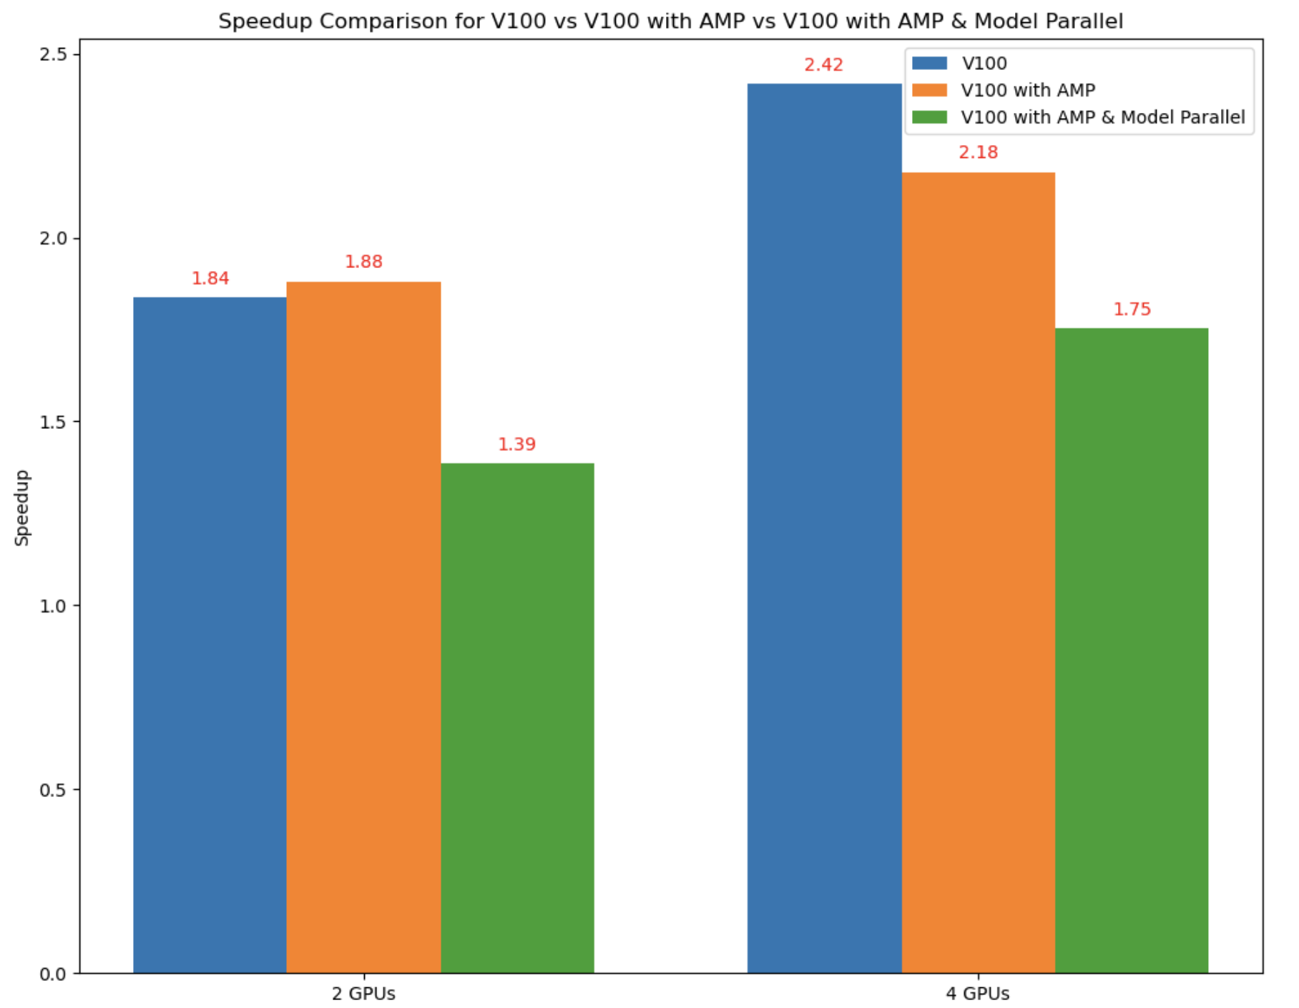 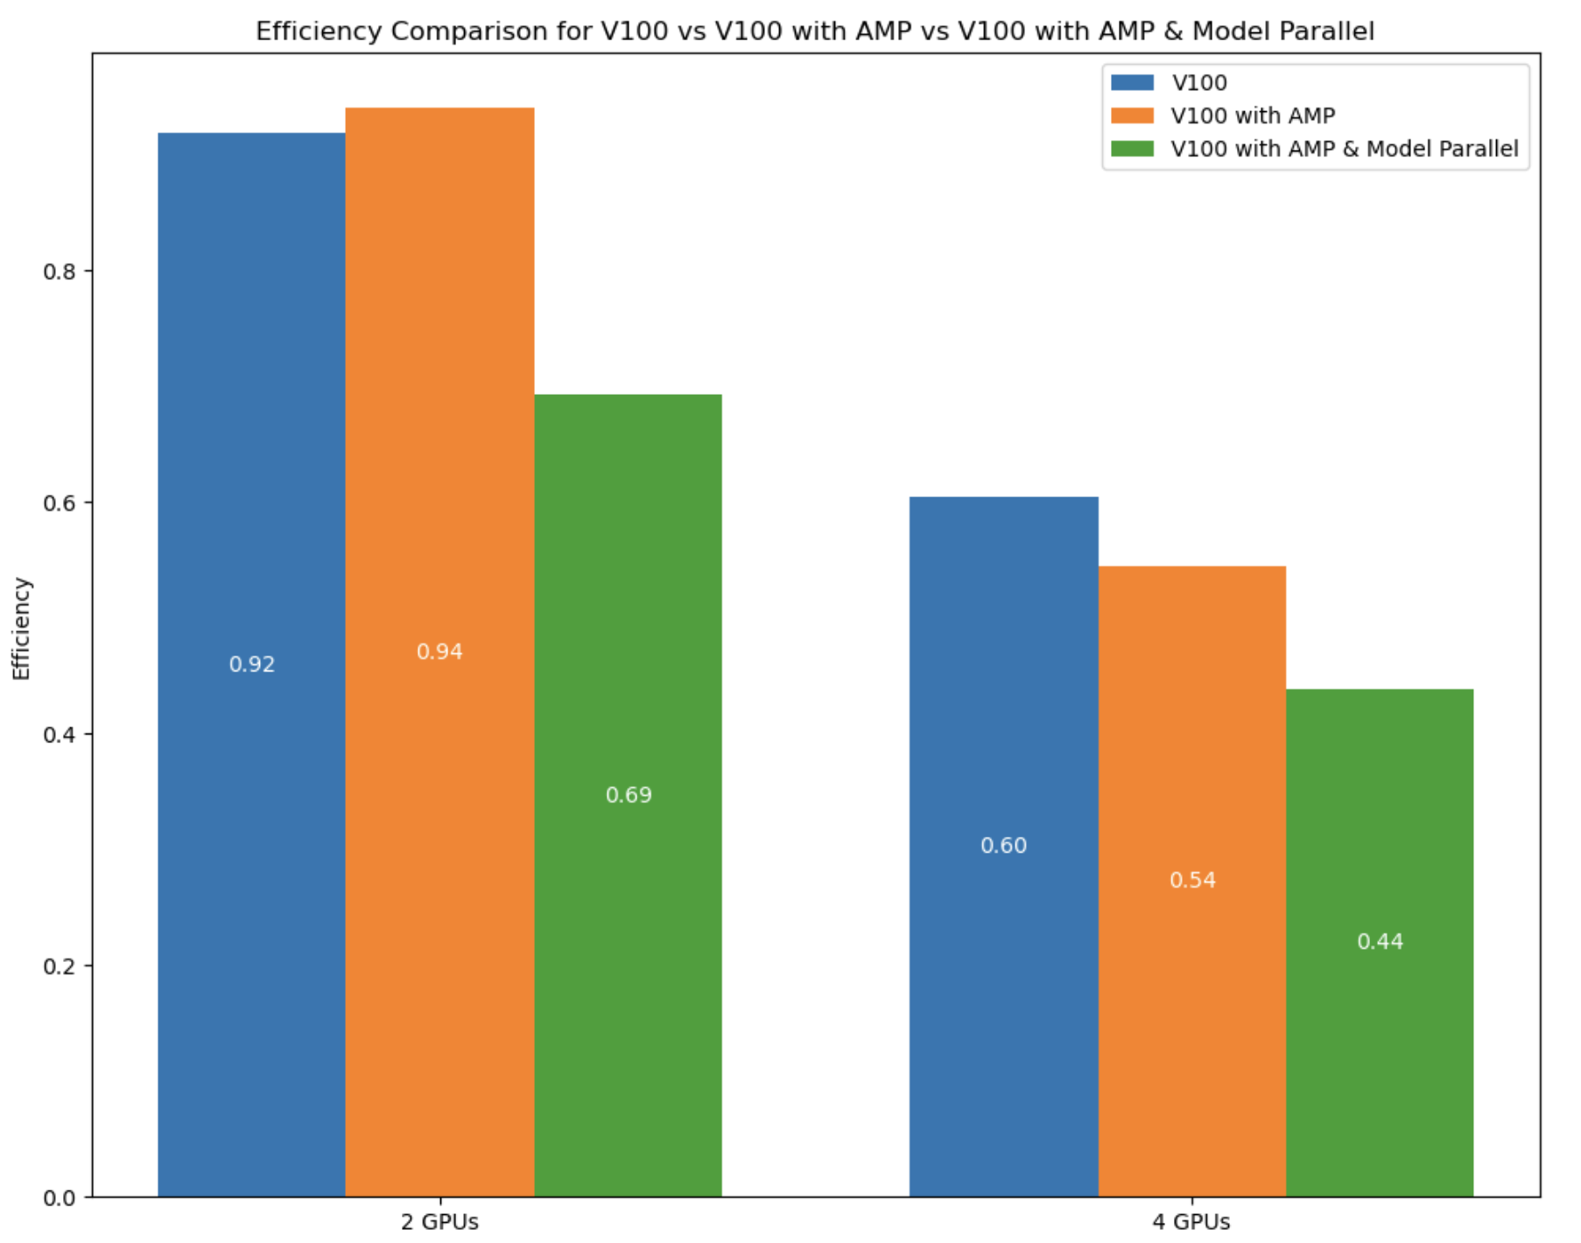

**Figure 19: Speedup and Efficiency for Model Parallel**

When looking at efficiency, V100 with AMP also performs well with efficiency values of 0.94 (2 GPUs) and 0.54 (4 GPUs). V100 with Model Parallel's efficiency, however, drops to 0.69 (2 GPUs) and further declines to 0.44 (4 GPUs), suggesting that, despite its ability to handle larger models, the efficiency does not justify its inclusion for smaller datasets or models that fit within a single GPU. The diminished efficiency when using Model Parallel implies that it is unnecessary for this project, where the model fits well in one GPU. Therefore, for optimal results in terms of training time, speedup, and efficiency, V100 with AMP is the best option. It provides a strong balance between reducing training time and maintaining high efficiency without the overhead of model parallelism.

# Conclusion:

In conclusion, this project has provided valuable insights into optimizing training performance using different configurations and parallelization techniques. Through my experiments, I learned how different batch sizes, data parallelism strategies, and hardware configurations impact the training time and efficiency of machine learning models. The key takeaway is that while scaling to multiple GPUs with techniques like DDP and AMP can offer performance improvements, the gains are not always linear, and the overhead of parallelism can decrease efficiency as the number of GPUs increases. For smaller datasets and models that fit within the capacity of a single GPU, using AMP with a standard configuration proves to be the most efficient and fastest solution.

For CPU-based training, using smaller batch sizes and optimizing data loading with multiple workers can lead to significant performance gains. The speedup and efficiency results showed that utilizing 2–4 CPU workers strike a good balance between reducing training time and maintaining efficiency. As for the GPU side, for this project, leveraging V100 with AMP provides the best combination of reduced training time and high efficiency. While introducing Model Parallelism provides some benefits for larger models, it does not offer noticeable improvements for this specific project, as the model fits well within the capabilities of a single GPU. Therefore, my recommended approach for both CPU and GPU setups would be to use AMP for GPU training with a batch size of 32 for efficient utilization of computational resources while ensuring the best performance and manageable training times.

# References:

[1] <https://pubmed.ncbi.nlm.nih.gov/24974815/>

[2] He, K., Zhang, X., Ren, S., & Sun, J. (2016). Deep Residual Learning for Image Recognition. *CVPR 2016.* [<https://arxiv.org/abs/1512.03385>]

[3] Hu, J., Shen, L., & Sun, G. (2018). Squeeze-and-Excitation Networks. *CVPR 2018.*  
[<https://arxiv.org/abs/1709.01507>]

[4] Chen, L. C., Papandreou, G., Kokkinos, I., Murphy, K., & Yuille, A. L. (2017). Deeplab: Semantic Image Segmentation with Deep Convolutional Nets, Atrous Convolution, and Fully Connected CRFs. *PAMI.* [<https://arxiv.org/abs/1606.00915>]

[5] https://www.kaggle.com/datasets/sabari50312/fundus-pytorch/